**Sprint 4 Plan: Spotify X Apple Music Blend, 5/21/24**

∙ **Goal:** We want to make the product more user-friendly, allowing individual songs to be played and letting the user see who contributed what to the playlist.

User Story 4: As a user, I want to see which songs in the playlist came from me and which came from my friend.

*Task 1: Include which user a song comes from in the track object (2 hr)*

*Task 2: Improve upon the algorithm to ensure the playlist is fairly equal (6 hr)*

*Task 3: Update the frontend UI to present the list of songs with who listened to them (5 hr)*

*Total for user story 4: 13 hours*

User Story 5: As a user, I want to be able to listen to individual songs in the blend rather than the whole playlist.

*Task 4: Embed individual songs via Spotify API (3 hr)*

*Task 5: Update the frontend UI to allow for a play button for each song (4 hr)*

*Total for user story 5: 7 hours*

*Total for sprint 4: 20 hours*

∙ **Team roles:**

*Neha: Project Owner, Developer*

*Kaustubh: Developer*

*Bode: Developer, Scrum Master*

*Justin: Developer*

*Chris: Developer*

*Shayan: Developer*

∙ **Initial task assignment:**

*Neha: User story 4/5, Task 1, Task 2*

*Kaustubh: User story 4, Task 2, Task 4*

*Bode: User story 4/5, Task 3, Task 4*

*Justin: User story 4, Task 4, Task 5*

*Chris: User story 4, Task 1, Task 2*

*Shayan: User story 4/5, Task 3, Task 5*

∙ **Initial burnup chart:**

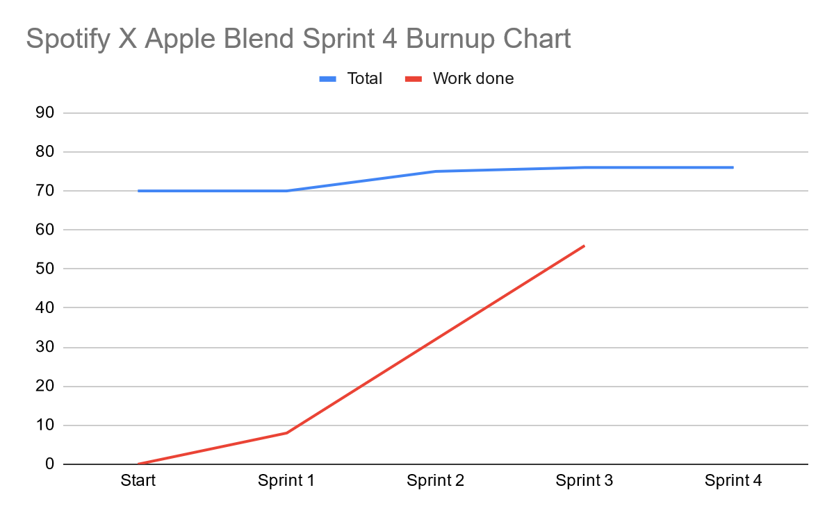

∙ **Initial scrum board:**

| **User Stories** | **Tasks Not Started** | **Tasks in Progress** | **Tasks Completed** |
| --- | --- | --- | --- |
| User Story 4: As a user, I want to see which songs in the playlist came from me and which came from my friend.  User Story 5: As a user, I want to be able to listen to individual songs in the blend rather than the whole playlist. | * *Task 1: Include which user a song comes from in the track object* * *Task 2: Improve upon the algorithm to ensure the playlist is fairly equal* * *Task 3: Update the frontend UI to present the list of songs with who listened to them* * *Task 4: Embed individual songs via Spotify API* * *Task 5: Update the frontend UI to allow for a play button for each song* | * *n/a* | * *Task 1: Improve upon the blend algorithm* * *Task 2: Cleaner frontend to present webapp features* * *Task 3: Look into how to play the music in the site* * *Task 4: Implement music player functionality* |

∙ **Scrum times:**

* Thursday 6:00 - 7:00 PM TA/tutor meeting
* Saturday 1:00-2:00 PM
* Wednesday 2:00-3:00 PM